To pay the annual LCRA membership fees online via credit card, please follow the below instructions.

- Login to your membership portal by clicking here.

  - If you do not know your credentials, or do not have a login currently setup for the membership portal, please contact the LCRA Office for assistance (call 403.254.4148 or email at info@lakechap.ca).

- Once you login, select the “My Info” tab at the top of the screen (should be next to the “LCRA Documents” tab).

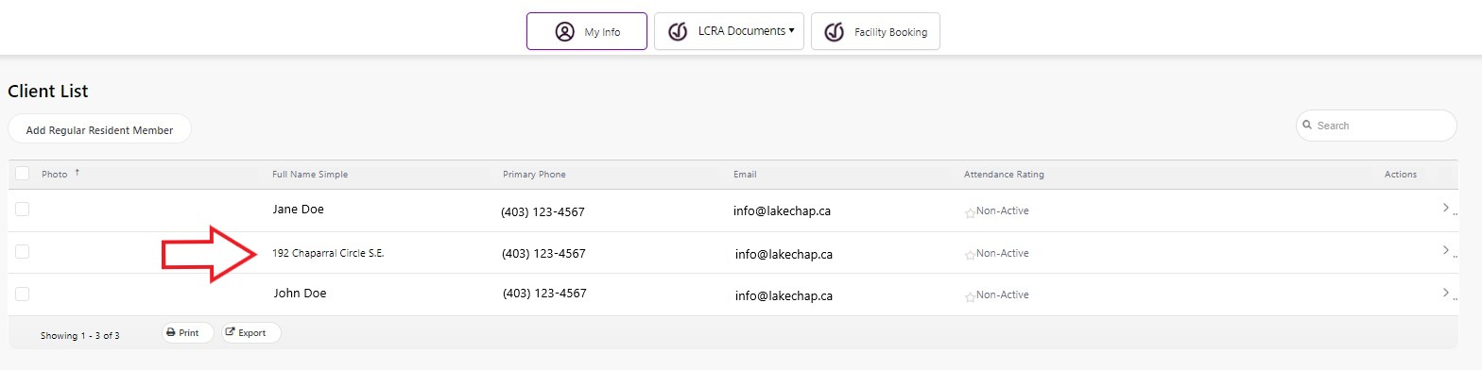
- The screen should display the “Client List”, a list of individuals listed as residing at your property. There will also be a line showing the property address – please click on this line (detailed in the picture below).

- This should take you to the profile screen for your property; select the “Invoices” tab from the options above your profile icon (far right).

- Once you are on the Invoices page, click the checkbox for the listed invoices (due date should be listed as July 1st of the current year). This step is shown in the picture below.

- Once the correct invoices are selected, the “Make Payment” button (located above the invoice checkboxes) should light up blue; click this button (also detailed in the picture below).
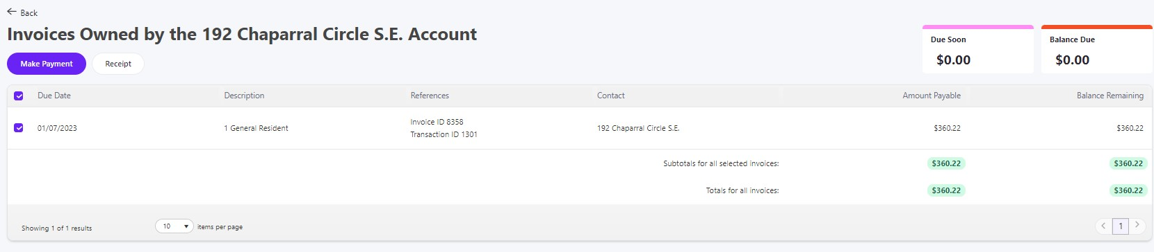
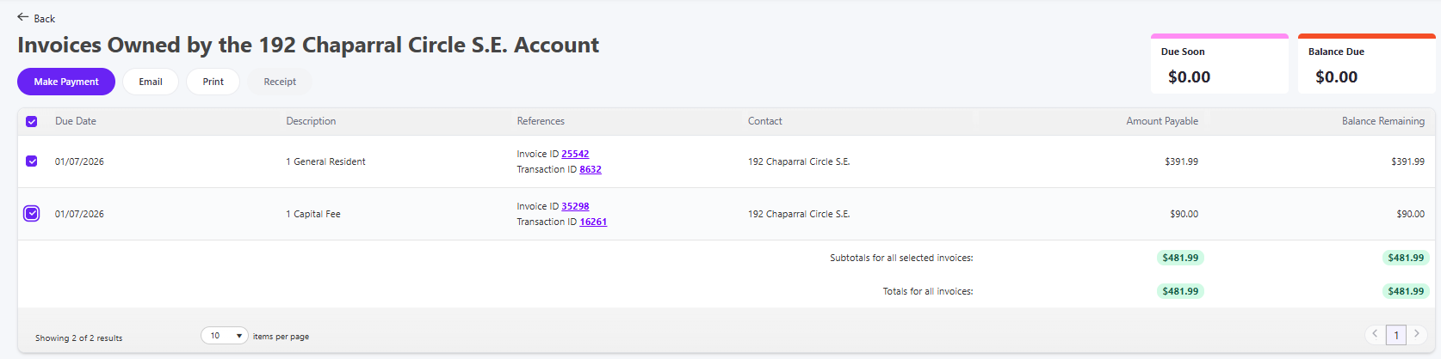

- A window titled “Pay Your Invoice” will pop up; double-check the Totals to make sure the amount is correct.

- Enter your credit card details, then select the blue “Complete” button.

  - A 2% service fee is applied to online credit card transactions; this amount simply covers our merchant fees for credit card transactions.

- Assuming the payment goes through, you should be able to then print or view a receipt of the transaction.

- You’re good to go! Your annual membership fee payment has been made.

--

If you have any questions, or if there are any issues with the payment, please contact the LCRA Office for assistance.

